INTERNETWORKING ESSENTIALS CA1

BACHELOR OF TECHNOLOGY
Computer Science & Engineering

By

MALLA SAMEER
SECTION-K23UP
Roll no: 24
Reg.No: 12315061

TO
Mr. Singh Malhi Sir



LOVELY PROFESSIONAL UNIVERSITY
PUNJAB INDIA

Project24: You are hired as a network engineer for Tlink Network Solutions, a mid-sized enterprise with a 7-floor office building. Each floor is equipped with 7 computers, and the organization requires a well-structured network to ensure efficient communication and scalability.
Network Design Requirements: 1. Topology Selection: Design a star topology for first 2 floors, mesh topology for next two floors, and ring topology for remaining floors, considering performance and fault tolerance.
2. IP Addressing Scheme: The company has decided to use Class C private IPv4 addresses for first two floors, Class A private IPv4 addresses for next two floors, and then Class B public IPv4 addresses for remaining floors following a classful addressing scheme. Allocate IP addresses properly for each floor, ensuring uniqueness.
3. Routing Strategy for Inter-Floor Communication & Connectivity: Recommend a routing approach that is dynamic for inter-floor communication.
• Design how the floors will be connected for seamless inter department communication.
• Suggest the appropriate network devices (e.g., switches, routers, access points) and their placement.
• If using dynamic routing, suggest an appropriate routing protocol (e.g., RIP, OSPF, or EIGRP) with justification.
• If using static routing, define the static routes for efficient data flow. • Specify the number of default gateways along with IP addresses.
Report Writing: Write the project report, which includes all the above things along with the labeled network scenario, and also mention the innovation done by you in the project.
Then upload the project on GitHub as well as check the engagement level of the project uploaded on GitHub.

Star Topology for first 2 floors:-

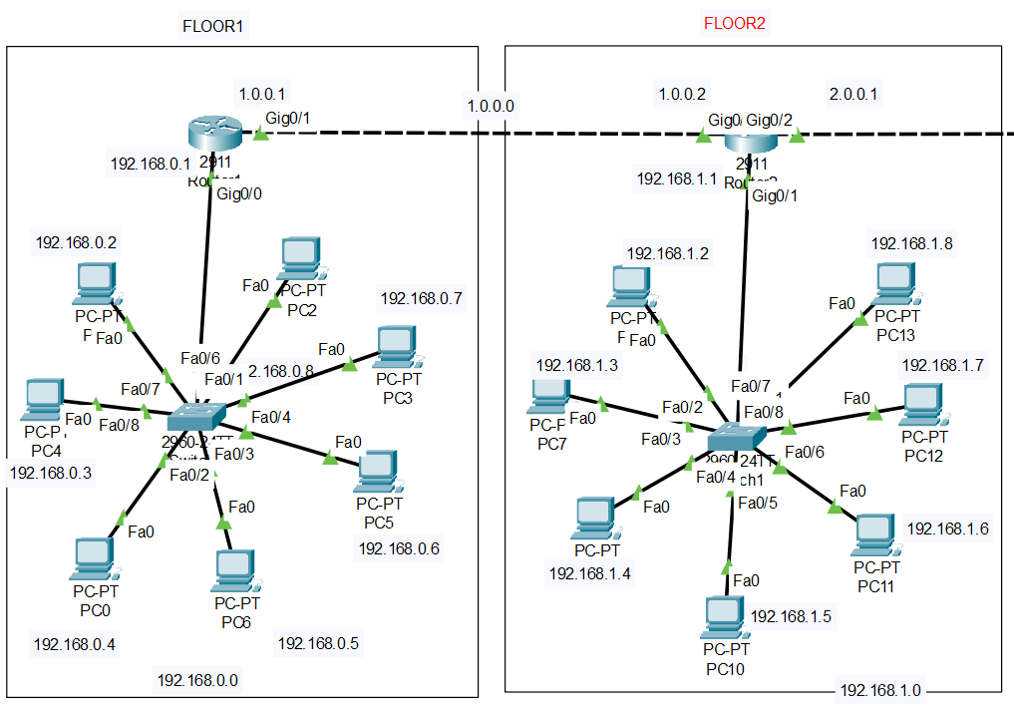

Mesh Topology for next 2 floors:-

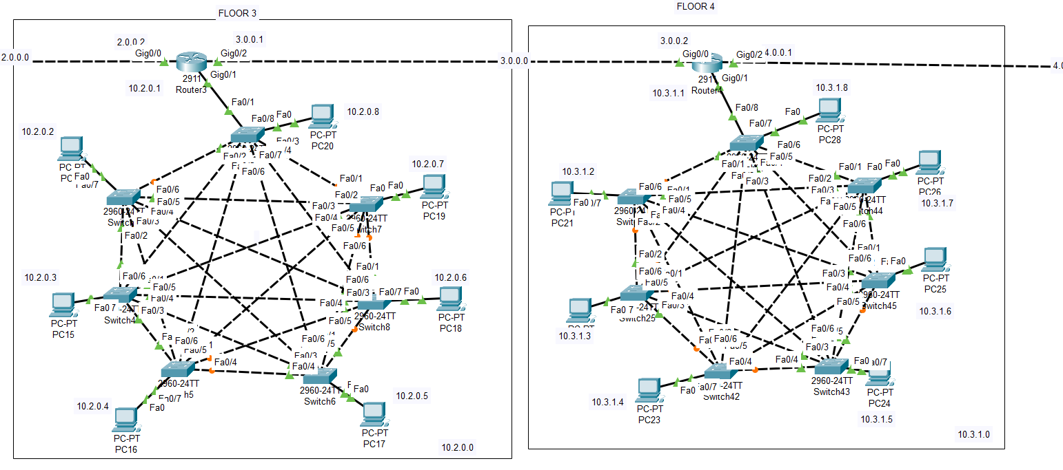

Ring topology for next three floors :-

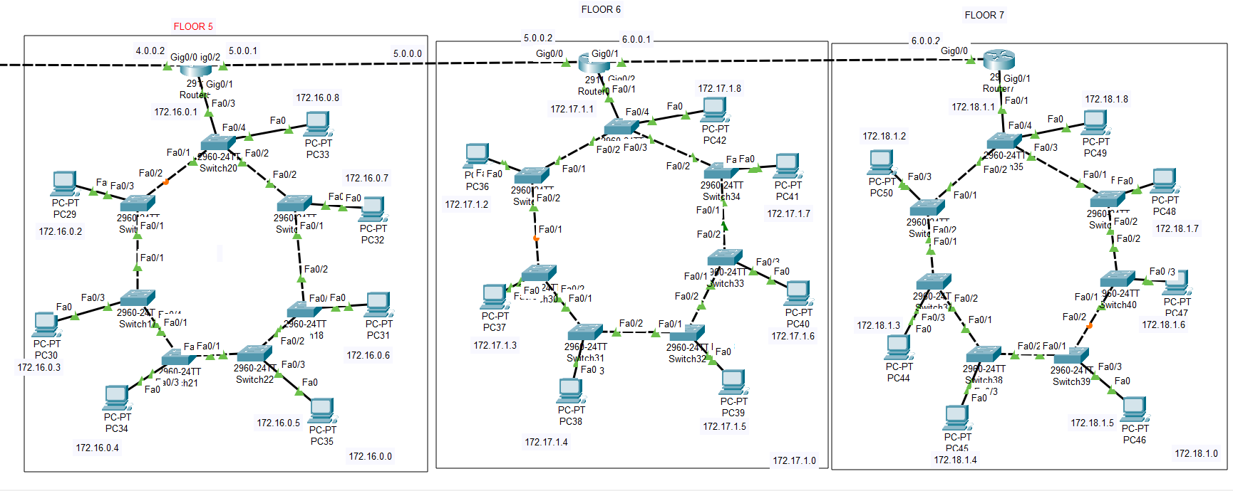

Entire building with complete setup

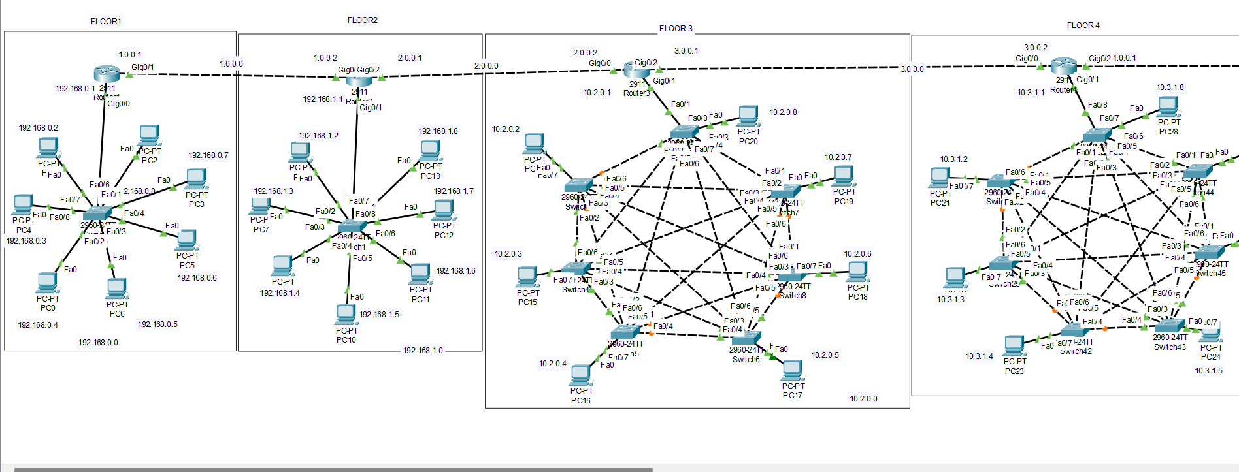


  - Allocation of IP Address:
1st Floor:
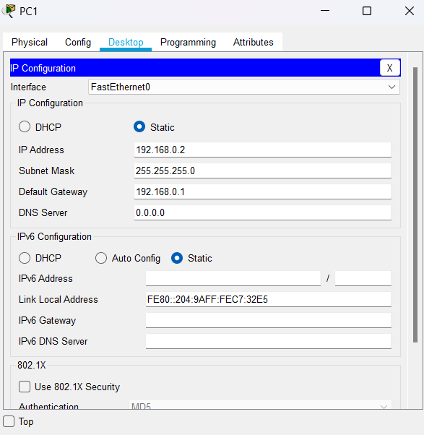

2nd Floor:
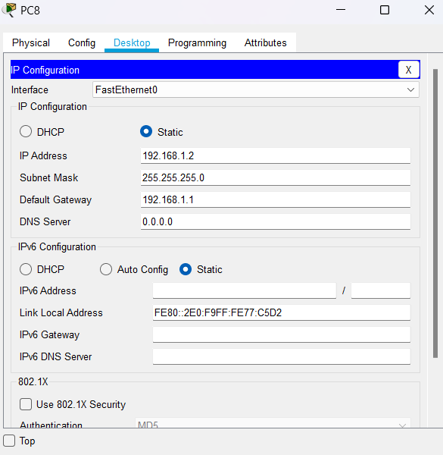

3rd Floor:
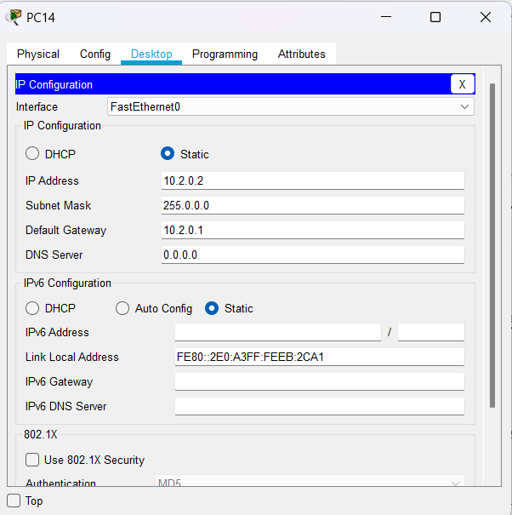

4th Floor:
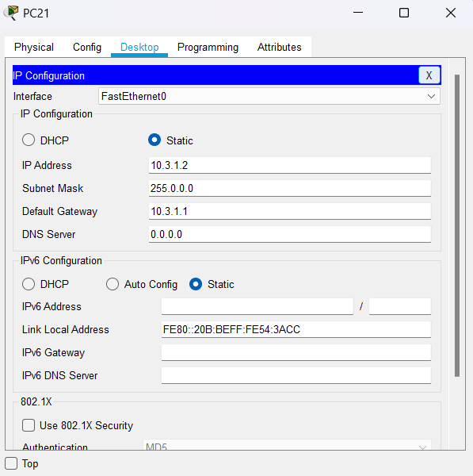

5th Floor:
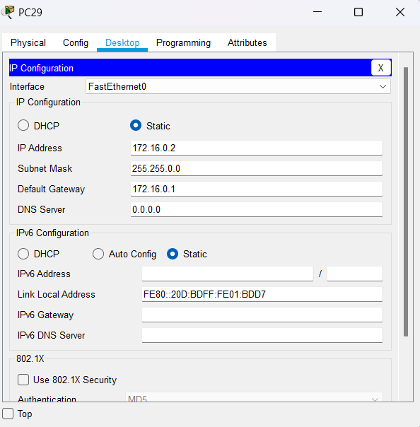

6th Floor:
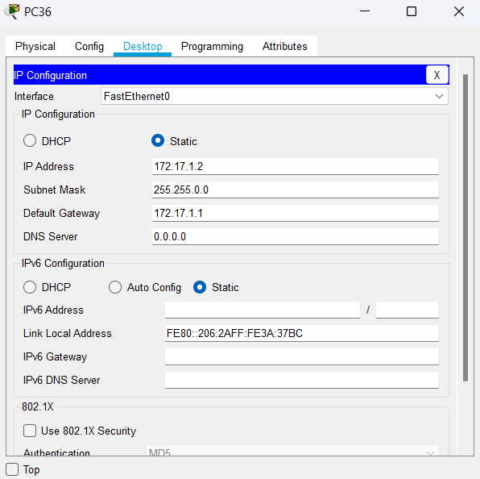

7th Floor:
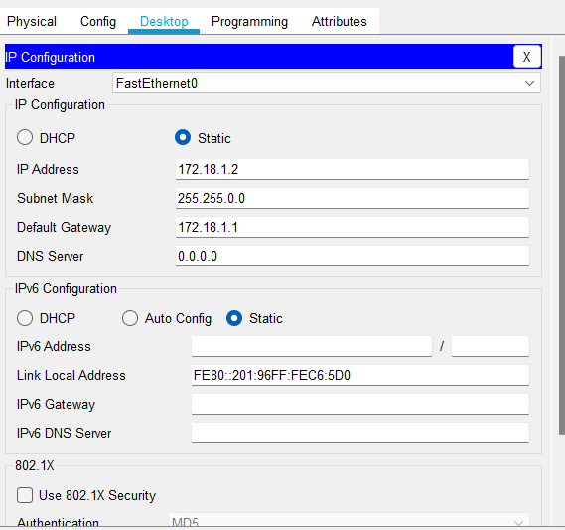

  - Dynamic Routing:

1st Router:
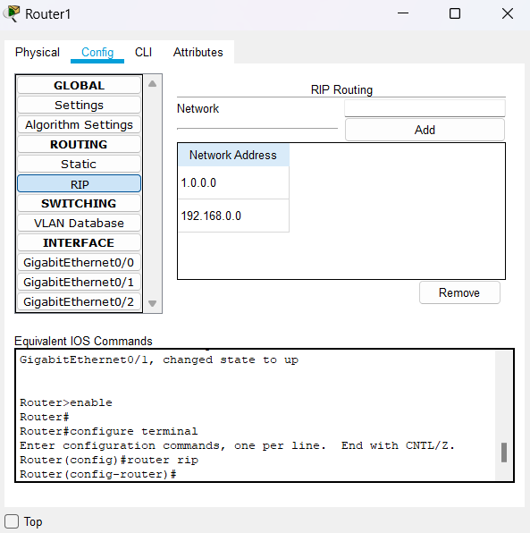

2nd Router:
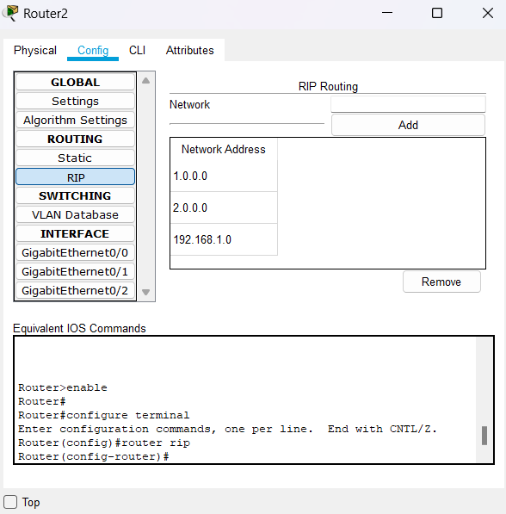

3rd router:
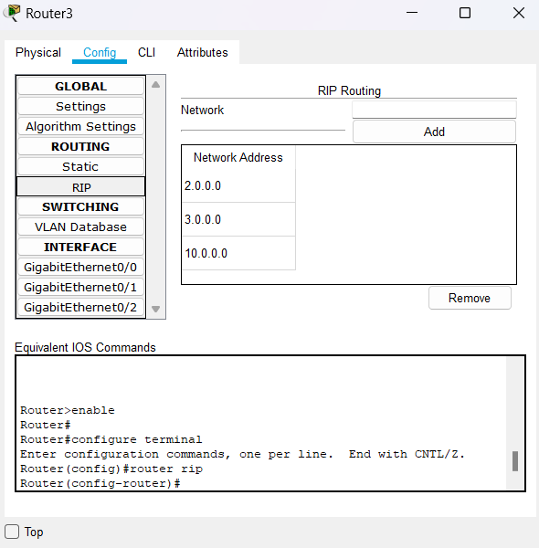

4th router:
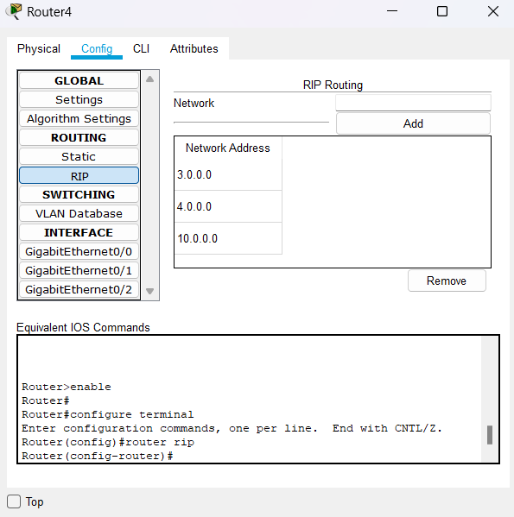

5th router:-
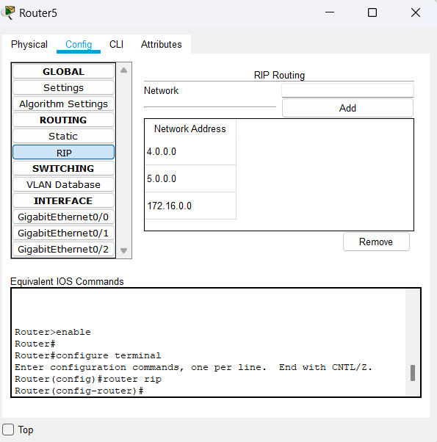

6th router:-
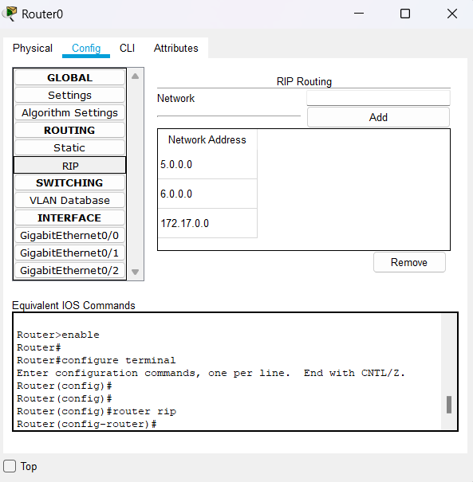

7th router:-
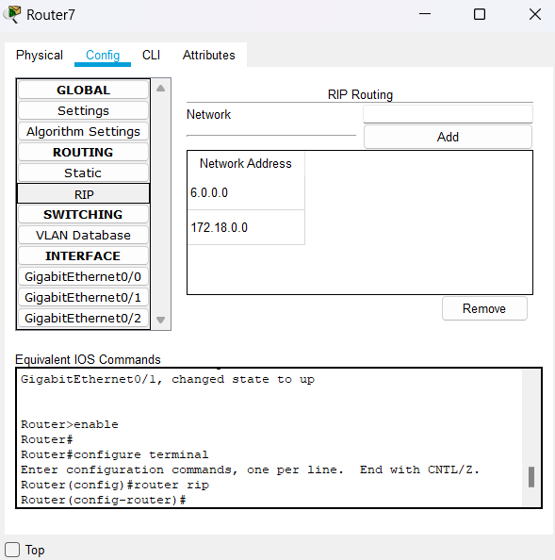

Communication between all computers:
1st Floor PC to Floor to all floors:
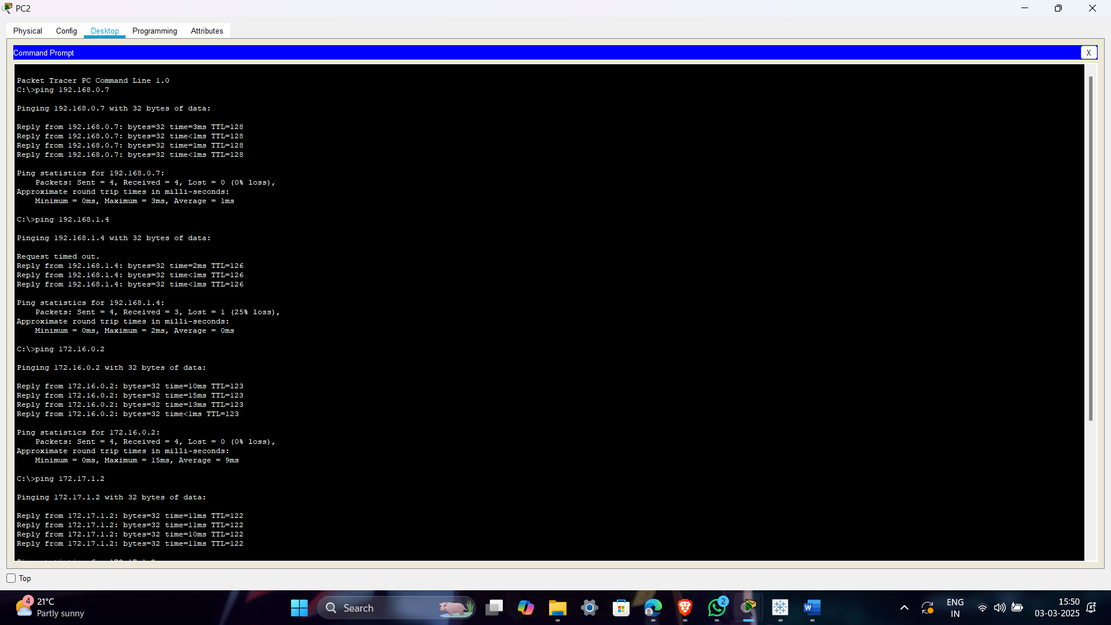

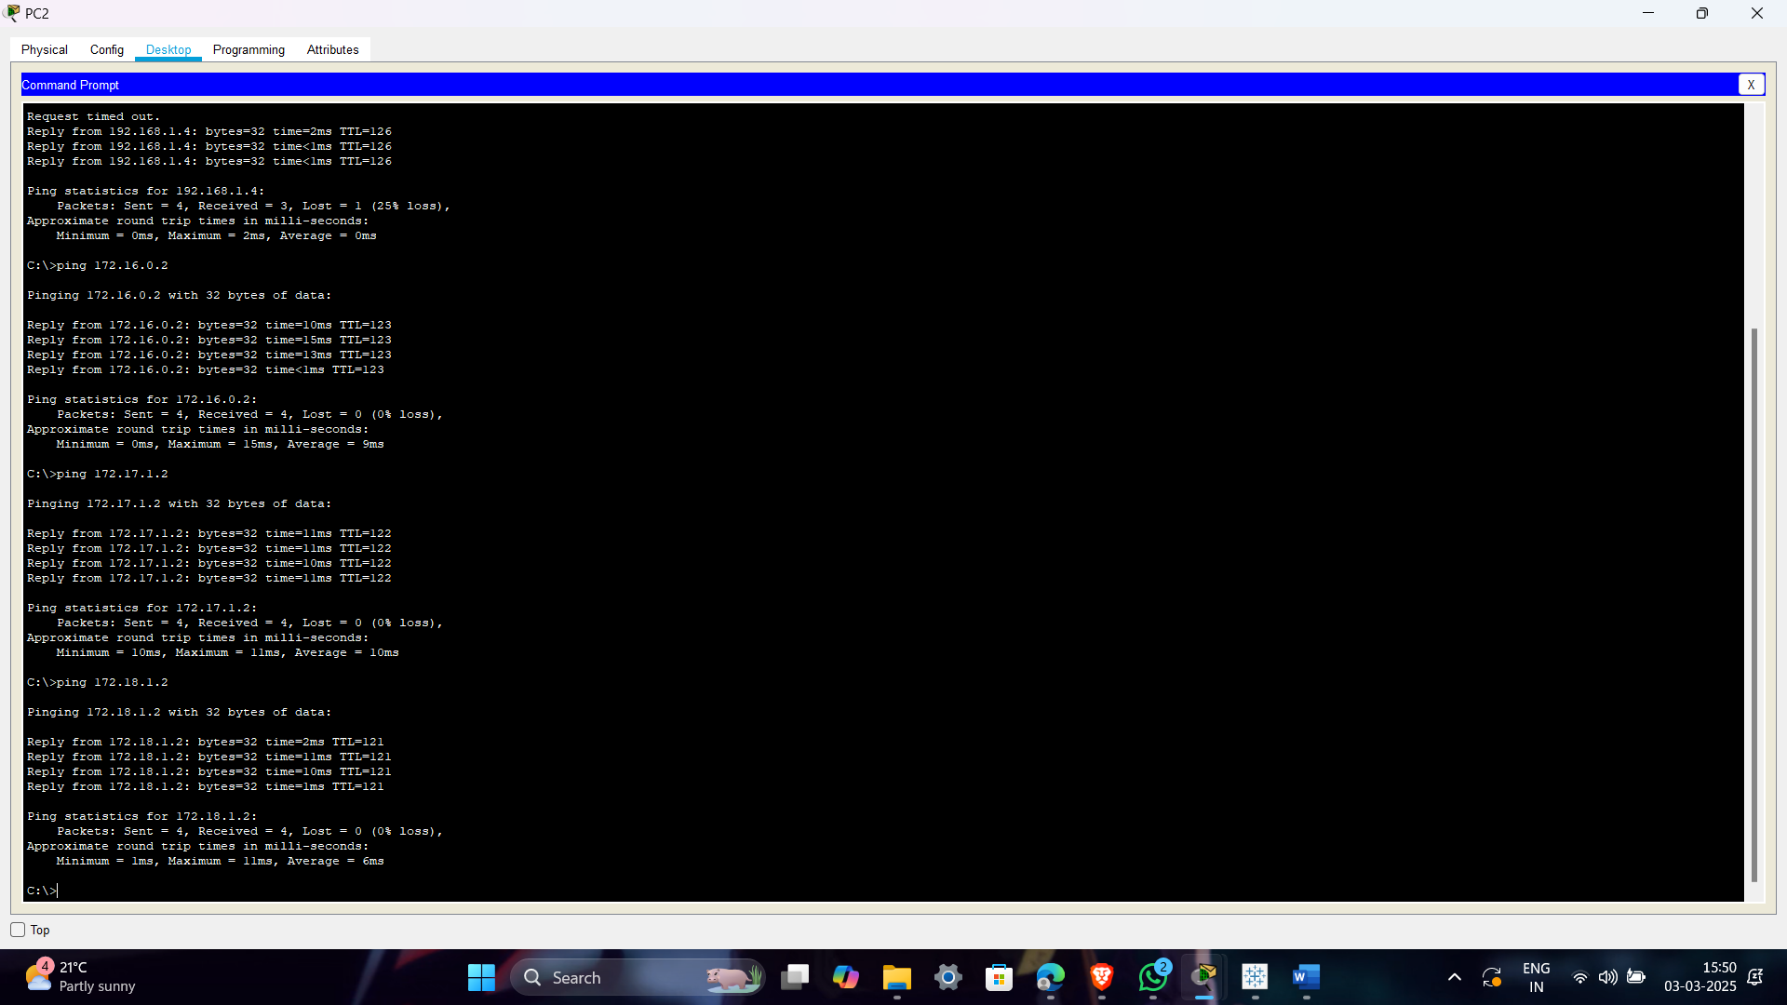
Last floor PC to all floor PC’s :

